Managed Print Services Guide for Schools

Table of Contents: Page

Introduction 1
Advantages of an MPS 1
Details of an MPS 2
Types of MPS contracts 2
Finance agreements with an MPS 3
Checklist for good practice for an MPS 3
Other considerations for an MPS 3

Introduction

A Managed Print Service (MPS) is a system/contract of print services (normally outsourced to a third party company) to manage all printing, faxing, scanning and copier devices on your network, school premises etc. in a cohesive way. By having an MPS schools can have the same models of printers and print/copiers, sometimes strategically placed in “common” areas to which teachers can print documents to. These documents are normally, for print/copiers, held in the “memory” of the device until such time as a teacher “picks them up”, usually by entering an individual pin code. There may also be “personal” and other network printers dotted around the school, but in a managed print service they are typically of the same brand and possibly model.
This removed the need to stock a myriad of different toners and maintenance kits for varying makes and models of printers that may have accumulated over the years in the school and for which in some instances, these replacement parts are “wasted” if the printer breaks down ‘beyond repair’. Without an MPS it is often very difficult for a school to have a clear understanding of the ‘total cost’ of printing as individual departments in a school may often manage their own printing requirements.

Advantages of an MPS

- Reduces costs and maintenance.
- Creates more efficiency.
- Provides clarity of print output.
- Standardization – instead of a multitude of different toners and printers, more streamlined and less potentially wasted inventory.
- Reduces your environmental footprint.
Ad-hoc
MPS

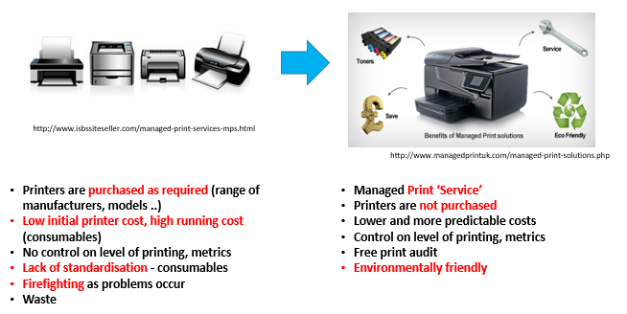
Details of a Managed Print Service

What is it?
It is a service which can:
- Monitor printing/copier devices so as to notify the print vendor that toner is low and consumables will be automatically sent to the school for the device.
- This could also manage/monitor users and the number of copies they make or limit their copying under particular criteria the school sets and agrees with the vendor.
- Can provide statistics on the number of B&W and/or colour copies for each device.
- Can send notifications to the MPS provider so as toner is dispatched to the school automatically.

How is the Service Managed?
- Usually managed through a Server on premise or cloud based OR
- If no server is available in a school, a local PC on the network can act as a Host server OR
- Users can print directly from a device to a printer (generally 3rd party software required here) OR
- Reports can be retrieved directly from the printing and copying devices

How is it Carried Out?
- Vendor specific software/3rd party software, some free some subscription based, is loaded onto a server which monitors all the devices. The server can be local (on premise) or cloud based or a school may use a PC as a host server (PC though would need to be left switched on), or some software can use “direct printing” from a device to a printer.
- Management can be as simple as monitoring usage so as toners are automatically dispatched and replenished to the “more detailed setup” of setting fixed allowances of copies per user, statistics of usage for each device and/or user and automatic notification to vendor to dispatch toners to the school.

Types of MPS Contracts

- Cost per Page price and pay only for what you use.
- Contracts with Print and Copy Volume Commitments.
- Tiered Billing.

Details

Cost per page – some schools can pay approx. 3-8 cent for B&W and 15-20 cent per page for colour. Schools should follow procurement practices i.e. check for an existing framework or seek quotations from at least 3 suppliers etc., as prices can vary greatly.

Monthly/Annul commitment copies – This is where a school “commits” to a fixed minimum number of copies. e.g. a school commits to use 125,000 copies but only uses at the end of the year 100,000 copies so may pay 25% more than they should. If you have a copier for a couple of years you can check the machine counter÷number of years=annual number of copies. This is a good indicator of what you need to commit to. Normally a vendor will audit existing printers and copiers and advise what a school needs to commit to.

Tiered billing – This is where you are charged different rates per page depending on the amount of toner the page uses. Charges may appear in the most expensive tier for a lot of your copying and how do you go about proving this after the fact – needs to be very clearly understood and interpreted with the vendor.

Finance Agreements with an MPS

A good way to spread cost but consider:

- Third Party Finance company versus
- Finance direct with equipment supplier.

Details
Finance – If financing/leasing large copier/printers ensure you understand the terms of the contract, length of contract (months/years), exit options or penalties etc. and interest rates. Also be aware of whether the company is regulated by the Financial Regulator.

Checklist for good practice for an MPS

- Decide on the type of MPS that fits your school i.e. manages consumables only, or also manages users, limits copies per user etc.

NOTE: Most MPS vendors will conduct an audit of your current usage with current printers/scanners/copiers and provide options for a complete new MPS system or phased in MPS system. Ultimately the vendor should

- Audit and Evaluate current usage, costs etc.
- Provide advice re Changes and what that would mean i.e. change in print devices/copiers, and the costs, etc.
- Implementation of the new MPS System inc. training etc.
- Show Improvement in TCO to the school
- Review & Optimise

- Choose a quality product and a provider with a good track record with schools.
- Seek references from other similar sized schools from the providers.
- Choose a cost type that suits your needs i.e. cost per page, volume commitment, tiered billing.
- Consider what technical support is included i.e. same day, next business day and hours etc.
- Consider the finance options to ensure the contract is clear, time “locked in to it, any additional support costs etc. and if the company providing the finance is regulated by the Financial Regulator.
- Where you already have a number of printers, consider, when purchasing or replacing these to introducing an MPS on a phased basis and eventually phasing out stand-alone printers of various makes and models which can be difficult, time consuming and costly to manage.

Other considerations to reduce cost/improve efficiency

- Set a B&W printer as the Primary Printer as opposed to the Colour Printer where possible.
- Even when purchasing smaller printers, add them to the MPS.
- Consider using Pin codes and mailbox printing to reduce waste.
- Set printers to print in Duplex (both sides of the page) or multiple pages per sheet where possible.
- Consider the paper quality and cost being used.
- Remote management of consumables & service ensures you are never without consumables or overstocking on consumables which may be “wasted” if the printer reaches end of life before all the inventory is used up.

For additional queries on MPS schools can email ictadvice@pdst.ie

