**Technical Support Guide for Schools**

**Table of Contents: Page**

The importance of Technical Support 1

A self-review checklist for schools 2

Improving Technical Support 2

School Role in Technical Support 4

Selecting technical support providers 4

School Digital Technology Infrastructure (DTI) Audit 5

DTI Technical Support Request for Quote (RFQ) – Template 6

**The Importance of Technical Support**

Given the increasing complexity of Digital Technology Infrastructure (DTI) in schools, it is critical that a well thought out planned approach to technical support is in place. Schools that have a high quality technical support process in place with suitable external IT providers benefit greatly from this model, as IT providers can focus their technical expertise on the technical areas, such as having a high quality, robust and reliable DTI in place, and this enables the school to focus their energies and expertise on teaching and learning areas to support students.

**The purpose of technical support is to ensure that the school has a robust Digital Technology Infrastructure (DTI) which works well at all times. The recommended model should use a combination of preventative measures to avoid issues occurring, as well as resolving issues when they arise.**

**While a common perception of technical support involves a reactive approach of resolving issues ‘after’ they happen, the more important aspect of technical support is preventing issues happening in the first place. The prevention approach is the better and more strategic approach, because if problems can be prevented from happening this reduces the negative impact to staff and students. Also the preventative approach is significantly less expensive.**

The preventative approach is facilitated by having a combination of having:

1. A fit for purpose high quality DTI in place
2. A high quality technical support service in place from providers
3. Good processes and ongoing improvement in these processes

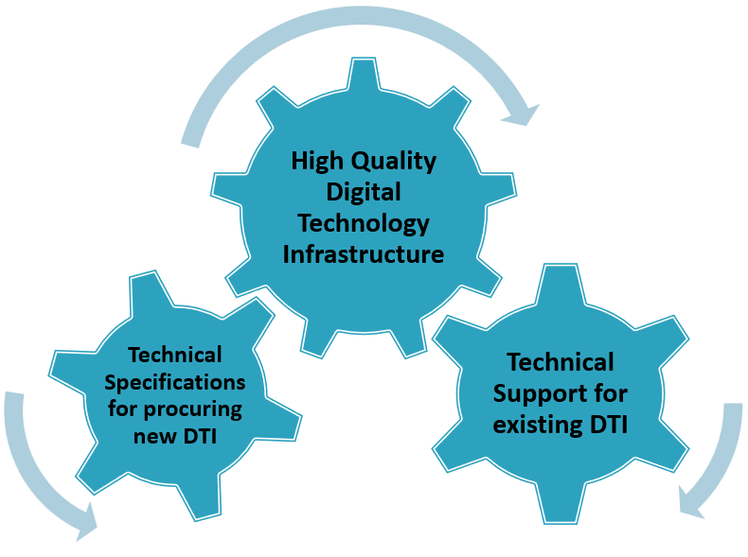

**There needs to be an ongoing focus on improving:**

* The quality of Digital Technology Infrastructure
* The quality of technical support services from IT providers
* The technical support processes between schools and IT providers

**A self-review checklist for schools**

In order for schools to plan how to improve technical support they need to review the current situation in the school to see how it could be improved. The following is a useful checklist of questions for schools in this regard:

* Does the existing technical support model meet school needs?
* Is there clarity between the school and IT providers regarding the services being provided?
* Are teachers happy that the existing technical support model works well?
* If school needs are not being met, what are the priority issues ?
* Are there actions which the school could take themselves to improve the model?
* Are there aspects of technical support that are currently provided by an IT provider that could more effectively be carried out by the school. Similarly are there aspects of technical support that are currently provided by the school that could more effectively be carried out by an IT provider?
* Have efforts been made to improve the model, and what if any progress has been made?
* Is the current model seen as expensive or giving good value for money?
* If it’s expensive, has a more cost effective model been discussed with existing IT providers?
* Is it always clear what the school is being charged for?

**Improving Technical Support**

Improving how technical support works includes changing from the ‘reactive’ model (as represented on the left) to a more strategic and proactive ‘preventative’ model (as represented on the right). These two models are summarised below.

**Reactive Model Preventative Model**

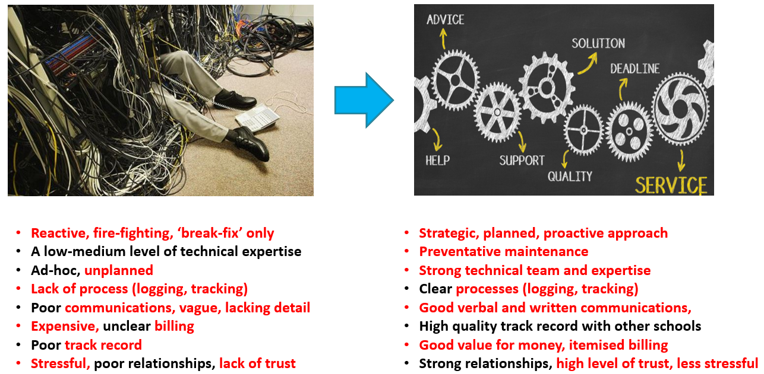

**School Role in Technical Support**

Technical support is not only about IT providers. The role of the school is essential to achieving successful a successful working model. There needs to be clarity regarding the role and responsibilities of schools vs the role and responsibilities of providers.

1. Schools need to review their technical support needs and their capacity within the school to identify:
   1. areas where the school itself could provide their own technical support and
   2. areas that need to be provided by external IT providers

This involves the school listing all areas that require support, and then deciding the areas to be supported a) by the school and b) by IT providers

1. Schools should be able to reduce the costs of technical support by identifying areas that could be supported by the school itself. This could also be an opportunity to build some technical support capacity within the school, which will benefit the school over the longer term, by making it more self-sufficient and less dependent on external IT providers.
2. Table 1 gives examples of activities that require lower levels of technical expertise, and that could be carried out by school staff, where they have the capacity and skills to do so. It also gives examples of activities that are typically carried out by IT providers.



**Table 1: Example of activities that Schools may support vs activities supported by IT providers**

**Selecting Technical Support Providers**

A school needs to select one or more high quality IT technical support providers that can provide the technical support services they require, and at costs that are consistent with the school IT expenditure plan.

When selecting technical support providers it is important to realise that there is a mix of ‘high quality’ and ‘other’ IT providers that may want to work with schools. As such it is critical to have a process in place to make sure that a high quality provider is selected by your school.

**Characteristics of High Quality Technical Support providers**

High quality technical support providers have the following characteristics:

* + They have high levels of technical expertise in relevant areas for schools
  + They manage technical support in an organised, professional manner
  + They have a strong customer focus, and treat schools as valued customers
  + They have high quality processes in place to support schools
  + Their written and verbal communications are of high quality. They also help schools by explaining complex issues in ‘plain english’.
  + Issues can be raised by schools via phone and email. Being able to raise issues via a service providers website, (24 x 7 etc), via an easy to use online support system is an added advantage.
  + Good value for money, clear and easy to understand, clear and itemised billing

**Unfortunately there are ‘other’ IT providers who are not providing the type of high quality service described above. These providers may have the following characteristics:**

* + They have poor or inconsistent levels of technical expertise
  + They approach technical support in an ad-hoc, un-professional manner
  + They lack customer focus, and don’t treat schools as valued customers
  + They seem more interested in having recurring monthly payments rather than fixing IT issues
  + They are likely to have poor quality processes in place
  + Their verbal and written communications are often unclear, vague, lacking in detail and difficult to understand. They don’t explain issues in ‘plain english’, to assist schools understanding of DTI
  + They offer poor value for money, by providing a low quality service, however with high charges
  + **Alert:** If a schools current IT provider has these type of characteristics, they should consider seeking a different high quality IT provider

**Technical Support arrangements / contracts**

* In general for schools to have a ‘suitable arrangement’ or ‘contract’ in place with IT providers makes good sense, but only where the contract helps the school in improving DTI to support teaching and learning.
* In some cases IT providers may use IT contracts in a ‘negative or controlling way’ to tie schools into rigid long term arrangements. This should not happen. Where schools have concerns in this regard they are welcome to email PDST-TiE at [ictadvice@pdst.ie](mailto:ictadvice@pdst.ie) .
* Schools with existing technical support arrangements in place with IT providers need to review these to check if they are still fit for purpose and meeting the needs of the school.
* Where schools have an existing ‘arrangement’ or ‘contract’ in place with high quality service providers (as described above), and where there is ongoing process improvement, then it would make sense to continue working with the IT provider.
* Alternatively where current arrangements are not meeting school needs, this raises concerns regarding the quality of technical support. In such cases schools may need to consider changing to a provider who has the capability to support their needs.
* Where a school has a low level of satisfaction with their current technical support provider, it would be advisable not to enter into a further long term contract.

**Contract and Billing Models for Technical Support**

A number of different billing models may apply including:

* Payment for services after they are provided (ie., pay as you go), without having a contract in place. The advantages of this approach is that it allows schools to assess the quality of the IT provider to meet their needs, without having to enter into a long term contract.
* Payment for a number of hours of service in advance (ie., known as ‘block hours’, then schools ‘draw down’ or use these hours as they are needed). This model may be suitable for schools, and the model allows schools to assess the quality of the service provider, without having to enter into a long term contract.
* A monthly, quarterly or yearly contract where charges include an flat monthly payment each month, which includes a set of services, such as ‘network monitoring’. On top of this flat monthly fee, additional charges apply for issues that arise and need to be addressed.
* In general where a school has never previously worked with an IT provider they should generally not enter into a long term yearly contract. Instead a shorter, less formal arrangement, either a ‘pay as you go’ model or an initial 3 to 6 months period may be a better, as it allows both parties to work together, and to ensure that the arrangement is working well, before entering into a longer term contact.

**Areas where technical support is required:**

The template request for quote (RFQ ) below provides a list of the different areas in which schools can specify the areas in which they need technical support. Schools can add/modify or delete these areas, and add their own requirements to suit their particular situation.

**Working with IT Providers, setting priorities:**

When a technical support IT provider is in place schools then need to work in collaboration with them to put in place a high quality technical support service to address agreed priorities. This is an ongoing process. It begins by setting priorities as to what areas need to be addressed initially, including any urgent items. These might include areas such as data and cybersecurity checks to make sure schools data is secure, or upgrading the school WiFi to make sure it can be accessed consistently in all areas within the school building.

**School Digital Technology Infrastructure (DTI) Audit**

An DTI Audit is recommended by PDST-TiE for schools to check the status of their DTI, to make sure it is fit for purpose, robust and meets recommended minimum technical specifications.

* The DT Audit should check if the school DTI meets recommended minimum technical specifications which are listed in the DTI Audit template (below).
* The state or quality of DTI can be affected by a range of issues which can cause it to be degraded or no longer be fit for purpose. These issues may include increased demand on the network, equipment issues causing degraded performance, external factors, undiagnosed problems, configuration errors, out of date software, hardware issues, increased cybersecurity threats etc.,
* DTI Audits need to be carried out by professional IT provider(s) with the relevant level of technical expertise, and who have experience of working with schools
* Following the DT Audit, an Audit Report should be generated by the IT provider to the school.

**For additional advice and guidance on technical support schools can contact PDST-TiE at** [**ictadvice@pdst.ie**](mailto:ictadvice@pdst.ie)

**PDST-TIE Website Link:**

Our PDST-TiE website link on Technical Support is:

<https://www.pdsttechnologyineducation.ie/technology-infrastructure/technical-support/>

**DTI Technical Support Request for Quote (RFQ) – Template**

Where a school requires technical support to be provided PDST-TIE recommends that as part of the RFQ process the school should request that IT providers carry out a DTI Audit in the school, and provide a report with their findings to the school. A template is provided below for this purpose. Before a school issues an RFQ for technical support it should consider the following points:

* It should provide clarity to IT providers as to what technical support services it requires.
* Where a school already has IT provider(s) in place for certain services (for example supplying student devices, school WiFi or supporting the Learning Platform) and wants to continue working with these existing IT providers, they should state this clearly, so that IT providers are clear that the school is not seeking quotes for these services.
* Where a school already has IT provider(s) in place for certain services, but may be open to seeking new IT Provider(s) for these services, they should state this clearly.

**Technical Support Request for Quote (RFQ) Template**

The template below may be used by schoolsto seek technical support for their school. It includes a summary of these areas where support is being requested. Schools may add or delete areas as necessary to meet their specific requirements. It includes a ‘summary of recommended minimum technical specifications’ to inform IT providers on what is needed in the various areas. It also includes a request to carry out an ‘DT Infrastructure Audit’ in the school, as this is an important first step especially when engaging with new IT providers. It is recommended that the RFQ be sent to a number of (ideally 3 or more) IT providers.

**Dear Provider,**

The school requires technical support to be provided in a number of DT Infrastructure (DTI) areas outlined in this RFQ. As part of the RFQ for technical support IT providers are requested to carry out an DT Infrastructure (DTI) Audit in the school, and provide a report to the school with their recommendations. A table is provided below for this purpose.

**Summary of areas where technical support is required**

* School Network, including local firewall
* School WiFi
* School Server (if applicable)
* Teacher Devices
* Student Devices – which are owned by the school
* Learning Platform (eg., Microsoft 365 or Google Workspace for Education) review, set up and configuration
* Fixed Projectors (mainly in classrooms)
* School Printers
* Data Backup and restore process (Cloud service to be recommended)
* Cybersecurity Review, Data Management review
* Other areas
* Overall recommendations

IT providers should provide details of the work that will be needed to resolve issues including details to bring each DTI area up to recommended minimum technical specifications using the table provided below.



**Table of Summary Recommended Minimum Technical Specifications**

IT providers may charge the school for this DTI Audit service, as it will require them to visit the school to carry out the work, which could take between a few hours and a full day depending on the size of the school, the level of work involved etc.

It is understood and accepted by the school that as part of the DTI Audit process IT providers may need ‘login access’ to review certain areas. It is also understood and accepted by the school that some IT service providers may not be able to provide all the IT services listed in the RFQ. In such cases IT providers need to provide clarity as to which services they can support, and also the services it cannot fully support or can partially support. For example an IT provider may provide services for school networks, WiFi, firewall, server, anti-virus, data backup, cybersecurity, devices etc., but may not be in a position to provide services for learning platforms or projectors/interactive panels/visualisers/audio visual.

**Importance of a School DTI Audit**

**An DTI Audit is recommended by PDST-TiE** for schools to check the status of their DTI, to make sure it is fit for purpose, robust and meets the summary minimum specifications as outlined.

* The DT Audit should check if the school DTI meets the listed specifications
* The DTI Audit need to be carried out by high quality professional IT provider(s) with the relevant level of technical expertise, and who have experience of working with schools
* Following the DT Audit, an Audit Report should be generated by the IT provider which should include:
  + Details of the work required to be carried out to resolve issues
  + Details to bring each DTI area up to recommended technical specifications
  + Each DTI area to be classified as either fit-for-purpose or indicate the level of work required (eg., minor or significant upgrade, software upgrade, not fit for purpose, further investigation required etc.,)
  + Priority/urgency levels to be assigned to the recommended changes (eg., P1, P2 etc)
  + Itemised costs associated with the recommended changes to be included for each area.
  + This example below shows a one page summary overview from a typical DTI audit report. An DTI Audit spreadsheet is provided with the RFQ so that the IT provider can include the completed version as part of the Audit report to the school.





**Pricing**

IT Providers should include a breakdown of their proposed pricing for the different areas outlined.

End of document